*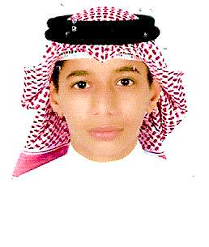****Osama Alsoofi***

**Address:**

Muharraq

block: 203

road: 321

buld: 784

**Phone**: 33964765 - 39811396

**E-mail:** osamaalsoufi692@gmail.com qaalsoufi@gmail.com

* ***Personal information:***

***Name****: Osama Abdulhameed Qassim Alsoofi*

***Birth of day****: 30/12/2001*

***Nationality****: Bahrini*

***marital******status****: single*

***Address*** *: Muharraq , block: 203 , road: 321 , buld : 784*

***Phone****:* 33964765 - *39811396*

***E-mail****:* [osamaalsoufi692@gmail.com](mailto:osamaalsoufi692@gmail.com) - [*qaalsoufi@gmail.com*](mailto:qaalsoufi@gmail.com)

* ***Education***

***Certificate:*** *General Secondary Certificate – Alhidaya Alkhalifia Secondary Boys School.*

***Major:*** *literary.*

***Rate:*** *76.5*

* ***Language***

|  |  |
| --- | --- |
| ***English***  ***Arabic*** | *good in speaking and in writing*  *Native language* |

* ***Work experience***

*2017* ***Muharraq Post Office*** *((Volunteer work))*

* ***Technical Proficiency***

|  |  |
| --- | --- |
| ***Platforms***  ***Applications*** | *Windows XP/Vista/7/10*  *Microsoft Office* |

* ***Additional Information***

1. *Ability to deal with a lot of customer.*
2. *Knowledge in use computer.*
3. *ability to bear all working condition.*
4. *Commitment to work schedules.*
5. *Good looking.*